STA 414 Assignment 2

Yubo Wang 1002138377

For question 1, 2, 3

clip_train_labels = np.argmax(train_labels[:10000], axis=1)  
clip_train_images = train_images[:10000]  
clip_bi_train_images = 1.0 *(train_images[:10000] > 0.5)  
clip_test_labels = np.argmax(test_labels[:10000], axis=1)  
clip_test_images = test_images[:10000]  
clip_bi_test_images = 1.0 *(test_images[:10000] > 0.5)

N_data, train_images, train_labels, test_images, test_labels = load_mnist()



MLE for $θ$:

$L=\prod_{i=1}^{10000}{p(x_{i}, c|θ, π)}=\prod_{i=1}^{10000}{p(c_{i}|π)}\prod_{d=1}^{784}{θ_{cd}^{xd_{i}}{\left(1-θ_{cd}\right)}^{1-xd_{i}} }$

$By setting\frac{dlog\left(L\right)}{dθ_{cd}}=0$, we have



$\hat{θ_{cd}}=\frac{\sum_{i=1}^{10000}{I\left(c_{i}=k\right)x_{di}}}{\sum_{i=1}^{10000}{I\left(c_{i}=k\right)}}$

MAP for $θ$:

$\hat{θ_{MAP}}=argmax\left(\prod_{i=1}^{10000}{p\left(x_{i}, c | θ, π\right)}\right)$

$M=\prod_{i=1}^{10000}{p\left(x_{i}, c | θ, π\right)} θ_{cd}(1-θ_{cd})$

$\frac{dM}{dθ_{cd}}=\frac{1}{θ_{cd}}-\frac{1}{1-θ_{cd}}+\frac{dlog\left(L\right)}{dθ_{cd}}$

${\hat{θ_{MAP}}}_{cd}$ = $\frac{1+\sum_{i=1}^{10000}{I\left(c_{i}=k\right)x_{di}}}{2+\sum_{i=1}^{10000}{I\left(c_{i}=k\right)}}$



def q1c(train_images, train_labels):  
  
 theta = np.zeros((10, 784))  
 train_labels = np.argmax(train_labels, axis = 1)  
 count_label =np.zeros(10)  
 for i in range(train_labels.shape[0]):  
 theta[train_labels[i]] += train_images[i]  
 count_label[train_labels[i]] += 1  
 for i in range(10):  
 theta[i] = (theta[i]+1) / (count_label[i] + 2)  
 save_images(theta, 'theta1.png')  
 return theta  
  
  
theta = q1c(train_images, train_labels)

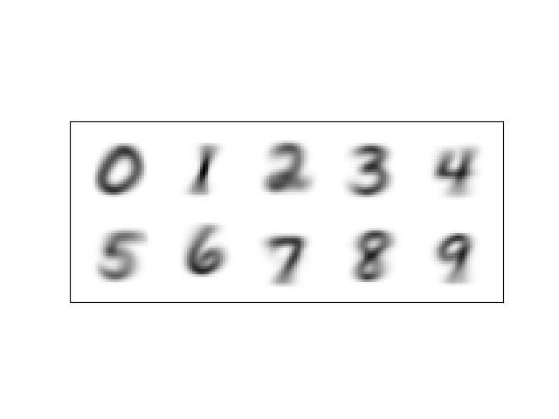





$\log{p\left(c | x, θ, π\right)}=\log{(p\left(x, c | θ, π\right)}-\log{(p(x|θ, π)}$

Since $p\left(c | x, θ, π\right)=\frac{p\left(x, c | θ, π\right)}{p\left(x | θ, π\right)}$

$p\left(x, c | θ, π\right)$ is expanded in the problem, $p\left(x | θ, π\right)=\sum_{i=0}^{9}{p(x, c_{i}|θ, π)}$



def p_x_given_c_theta(theta, x, c):  
 ones = np.ones((1, 784))  
 return theta[c, :] ** x.reshape(1, 784) * (1-theta[c, :]) ** np.subtract(ones, x.reshape(1, 784))  
  
  
def p_xc_given_theta_pi(theta, x, c):  
 result = np.prod(p_x_given_c_theta(theta, x, c))  
 result /= 10  
 return result  
  
  
def p_c_given_x(theta, data, c):  
 num = p_xc_given_theta_pi(theta, data, c)  
 denom = 0  
 for i in range(10):  
 denom += p_xc_given_theta_pi(theta, data, i)  
 return num / denom  
  
  
def average_log_llh(theta, data, labels):  
 result = 0  
 for i in range(10000):  
 if p_c_given_x(theta, data[i], labels[i]) == 0:  
 print("error")  
 log = math.log(p_c_given_x(theta, data[i], labels[i]))  
 result += log  
 return result / 10000  
  
  
def accuracy(theta, images, labels):  
 prediction = []  
 for i in range(10000):  
 computed_p = []  
 for c in range(10):  
 p = p_c_given_x(theta, images[i], c)  
 # print(p)  
 computed_p.append(p)  
 prediction.append(np.argmax(computed_p))  
 # print(prediction)  
 labels = np.array(labels)  
 prediction = np.array(prediction)  
 correct = prediction[prediction==labels]  
 correct_count = correct.shape[0]  
 return correct_count / len(labels)  
def q1e(theta, train_images, train_labels, test_images, test_labels):  
 print("Training set accuracy: {}".format(accuracy(theta, train_images, train_labels)))  
 print("Test set accuracy: {}".format(accuracy(theta, test_images, test_labels)))  
 return average_log_llh(theta, train_images, train_labels)  
  
print(q1e(theta, clip_train_images, clip_train_labels, clip_test_images, clip_test_labels))

Training set accuracy: 0.8366

Test set accuracy: 0.8445

Training average log likelihood: -3.142

Test average log likelihood: -2.977



True.



False.



def q2c(theta):  
 image = np.zeros((10, 784))  
 for iter in range(1, 11):  
 index = np.random.choice(np.arange(10), 1, p=[0.1] * 10)  
 print(index)  
 sample = []  
 for i in range(784):  
 prob = [theta[index, i][0], 1 - theta[index, i][0]]  
 print(prob)  
 s = np.random.choice(np.array([1, 0]), 1, p=prob)  
 sample.append(s)  
 sample = np.array(sample).reshape((1, 784))  
 image[iter-1,:] = sample  
 save_images(image, 'random_sample.png'))  
  
q2c(theta)

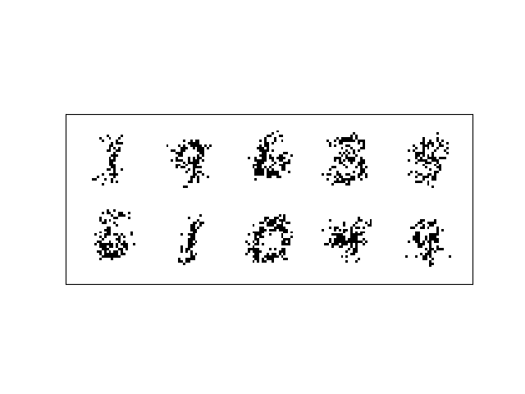









$p\left(x_{i}∈bottom | x_{top}, θ, π\right)$

$=\sum_{c=0}^{9}{p\left(x_{i}∈bottom | c, x_{top}, θ, π\right)}*p\left(c | x_{top}, θ, π\right)$

$=\sum_{c=0}^{9}{p\left(x_{i}∈bottom | c, x_{top}, θ, π\right)}*\frac{p\left(x_{top}|c,θ,π\right)p\left(c|θ,π\right) }{\sum_{c=0}^{9}{p\left(x_{top},c | θ,π\right)}}$

$=\sum_{c=0}^{9}{\left(θ_{cd}^{xd}{\left(1-θ_{cd}\right)}^{1-x_{d}}\right)}\frac{π_{C}\prod_{d=1}^{392}{θ_{cd}^{xd}{\left(1-θ_{cd}\right)}^{1-x_{d}}}}{\sum_{c=0}^{9}{π_{C}\prod_{d=1}^{392}{θ_{cd}^{xd}{\left(1-θ_{cd}\right)}^{1-x_{d}}}}}$

def q2e(x, theta):  
 x_top = x[:,:392]  
 theta_top = theta[:, :392]  
 joint_top = np.exp(np.dot(x_top, np.log(theta_top.T)) + np.dot(1-x_top, np.log(1-theta_top.T)))[:20]  
 full_new_theta = []  
 for i in range(20):  
 new_theta = []  
 for j in range(392, 784):  
 joint_bot = np.exp(x[i,j] * np.log(theta[:, j]) + (1-x[i,j]) * (1-np.log(1-theta[:,j])))  
 t1 = np.dot(theta[:, j], joint_top[i] * joint_bot)  
 t2 = np.dot(1 - theta[:, j], joint_top[i] * joint_bot)  
 new_theta.append(t1/(t1+t2))  
 full_new_theta.append(new_theta)  
 result = np.zeros((20, 784))  
 for i in range(20):  
 result[i][:392] = x[i][:392]  
 result[i][392:] = full_new_theta[i]  
 save_images(result, "q2e.png")  
  
q2e(clip_bi_train_images, theta)

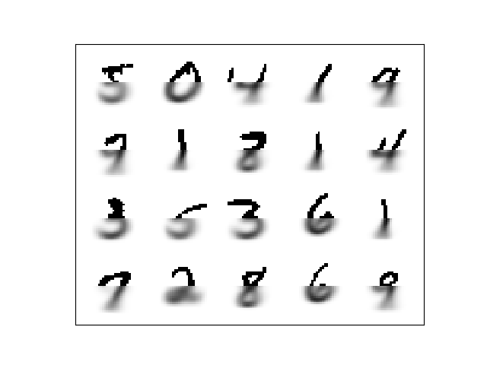






Number of parameter is 10*784 = 7840



To compute $∇_{wc'}\log{p(c|x, w)}$, we have two cases:

Case 1: $c≠c'$

$∇_{wc'}\log{p(c|x, w)}=\frac{\sum_{i=0}^{9}{\exp\left(w_{i}^{T}x\right)}}{\exp\left(w_{c}^{T}x\right)}*\frac{0-\exp\left(w_{c}^{T}x\right)\exp\left(w_{c'}^{T}x\right)x}{{\left(\sum_{i=0}^{9}{\exp\left(w_{i}^{T}x\right)}\right)}^{2} }$

$=-\frac{\exp\left(w_{c^{'}}^{T}x\right)x}{\sum_{i=0}^{9}{\exp\left(w_{i}^{T}x\right)}}=-p\left(c^{'} | x, w\right)x$

Case 2: $c=c'$

$∇_{wc'}\log{p(c|x, w)}=\frac{\sum_{i=0}^{9}{\exp\left(w_{i}^{T}x\right)}}{\exp\left(w_{c}^{T}x\right)}*\frac{\exp\left(w_{c}^{T}x\right)*\left(\sum_{i=0}^{9}{\exp\left(w_{i}^{T}x\right)}-\exp\left(w_{c}^{T}x\right)\right)x}{{\left(\sum_{i=0}^{9}{\exp\left(w_{i}^{T}x\right)}\right)}^{2} }$

$=\frac{\left(\sum_{i=0}^{9}{\exp\left(w_{i}^{T}x\right)}-\exp\left(w_{c}^{T}x\right)\right)x}{\sum_{i=0}^{9}{\exp\left(w_{i}^{T}x\right)}}=\left(1-p\left(c^{'} | x, w\right)\right)x$

By using the one of k encoding for label

We have matrix form for code:



$\left(label-\left[\begin{matrix}p\left(0 | x, w\right) \\ … \\ p\left(9 | x,w\right)\end{matrix}\right]\right)×\left[\begin{matrix}x \\ … \\ x\end{matrix}\right]$

def compute_prob(x, w):  
 return softmax(np.dot(w, x))  
  
  
def gd(x, c, w):  
 result = np.zeros((10, 784))  
 result[c, ] = x  
 x_tile = np.tile(x, (10, 1))  
 result -= np.dot(np.diag(compute_prob(x, w)), x_tile)  
 return result  
  
def lr(x, y):  
 w = np.zeros((10, 784))  
 ratio = x.shape[0] // 10000  
 for i in range(50):  
 for j in range(ratio):  
 t1, t2 = j * 10000, (j+1) * 10000  
 x_b = x[t1:t2]  
 y_b = y[t1:t2]  
 dw = sum([gd(x_b[k], y_b[k], w) for k in range(10000)])  
 w += 0.01 * dw  
 save_images(w, "q3c.png")  
 return w  
  
w = lr(clip_bi_train_images, clip_train_labels)

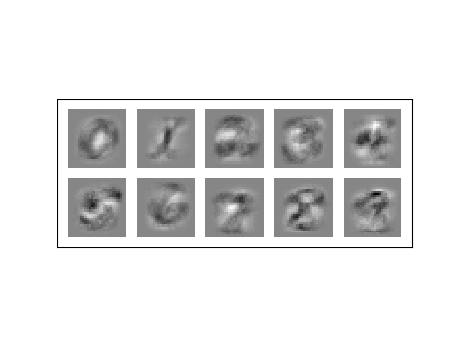





Training accuracy: 0.87

Training average log likelihood: -1.41

Test accuracy: 0.86

Test average log likelihood: -1.69



mu1 = np.array([0.1, 0.1])  
mu2 = np.array([6.0, 0.1])  
va = [10, 10]  
cova = 7  
VCVmatrix = np.array([[va[0], cova],  
 [cova, va[1]]])  
mvn1 = np.random.multivariate_normal(mu1, VCVmatrix, size=200)  
mvn2 = np.random.multivariate_normal(mu2, VCVmatrix, size=200)  
x1, y1 = mvn1.T  
x2, y2 = mvn2.T  
xc = np.concatenate((x1, x2))  
yc = np.concatenate((y1, y2))  
full_data = np.concatenate((mvn1, mvn2))  
true_label = []  
for i in range(200):  
 true_label.append(1)  
for i in range(200):  
 true_label.append(2)  
fig = plt.figure()  
plt.scatter(xc, yc, 24, c=true_label)  
# plt.show()  
fig.savefig("true-cluster.png")

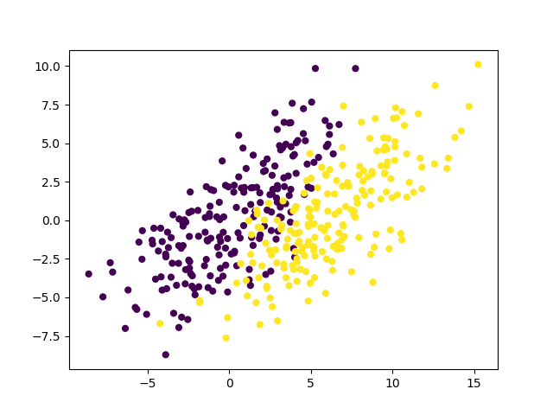





class K_Means:  
 def __init__(self, k=2, tol=0.0001, max_iter=50):  
 self.k = k  
 self.tol = tol  
 self.max_iter = max_iter  
  
 def cost(self, dp):  
 return [np.linalg.norm(dp-self.centroids[c]) for c in range(2)]  
  
 def km_e_step(self, data):  
 self.classifications = {}  
 cost = 0  
 for i in range(self.k):  
 self.classifications[i] = []  
 for d in data:  
 cost_lst = self.cost(d)  
 min_idx = cost_lst.index(min(cost_lst))  
 self.classifications[min_idx].append((d[0], d[1]))  
 cost += sum(cost_lst)  
 return cost  
  
 def km_m_step(self):  
 for c in range(len(self.classifications)):  
 self.centroids[c] = np.average(self.classifications[c], axis=0)  
  
 def fit(self,data):  
  
 # initialize centroids randomly  
 self.centroids = {}  
 idx_lst = []  
 for i in range(self.k):  
 idx_lst.append(random.randint(0, 400))  
 for i in range(self.k):  
 self.centroids[i] = data[idx_lst[i]]  
 print("Initial centroids: " + str(self.centroids))  
 optimized = False  
 i = 0  
 log_lst, iter_lst = [], []  
 while i < self.max_iter and not optimized:  
 i += 1  
 iter_lst.append(i)  
 cost = self.km_e_step(data)  
 log_lst.append(cost)  
 prev_centroids = dict(self.centroids)  
 self.km_m_step()  
  
 for c in range(self.k):  
 original_centroid = prev_centroids[c]  
 current_centroid = self.centroids[c]  
 print(original_centroid, current_centroid)  
 diff = np.sum((current_centroid-original_centroid)/original_centroid*100.0)  
 print("Iteration: {}. Shift: {}".format(i, diff))  
 if abs(diff) < self.tol:  
 optimized = True  
 print("finished")  
 fig = plt.figure()  
 for cent in range(2):  
 plt.scatter(self.centroids[cent][0], self.centroids[cent][1])  
 label = [0] * len(self.classifications[0]) + [1] * len(self.classifications[1])  
 full_cluster = np.concatenate((self.classifications[0], self.classifications[1]))  
 x_pos = full_cluster[:, 0]  
 y_pos = full_cluster[:, 1]  
 plt.scatter(x_pos, y_pos, 24, c=label)  
 fig.savefig("k_means_iteration{}.png".format(i))  
 wrong1, wrong2 = 0, 0  
 for i in data[:200]:  
 if (i[0], i[1]) not in self.classifications[0]:  
 wrong1 += 1  
 if (i[0], i[1]) not in self.classifications[1]:  
 wrong2 += 1  
 fig = plt.figure()  
 plt.plot(iter_lst, log_lst)  
 fig.savefig("cost_iter.png")  
 print("Error percentage: " + str(min(wrong1/200, wrong2 / 200)))

Iteration 1 Iteration 14

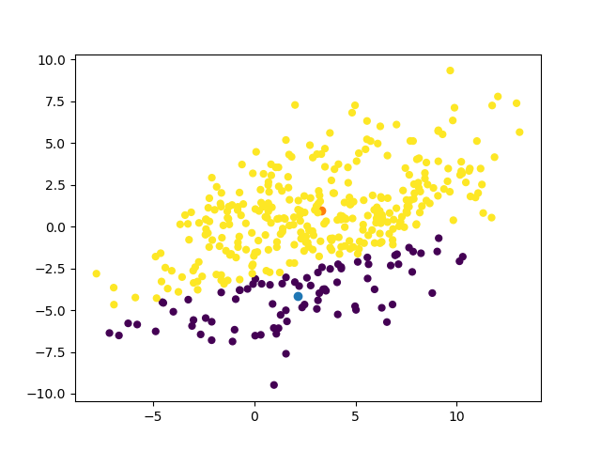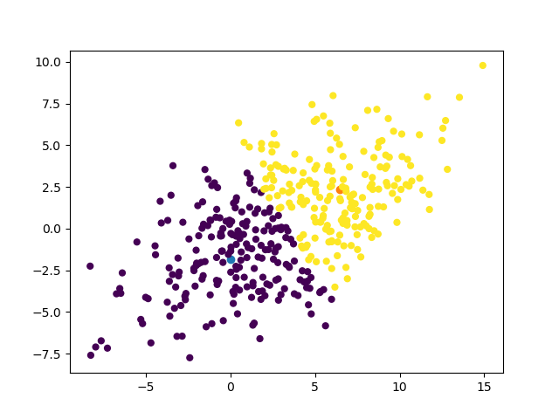

Error percentage: 0.235

Cost-iteration graph

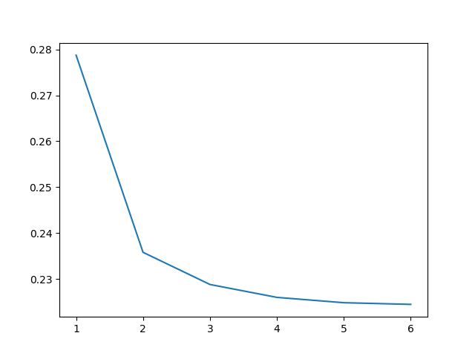

class EM:  
 def __init__(self, k=2, tol = 0.00001, max_iter=50):  
 self.imat = np.array([1, 0, 0, 1]).reshape(2,2)  
 self.mu1 = np.array([0, 0])  
 self.mu2 = np.array([1,1])  
 self.k = k  
 self.tol = tol  
 self.max_iter = max_iter  
 self.params = {'mu1': self.mu1, 'mu2': self.mu2, 'cov1' : self.imat, 'cov2' : self.imat, 'ratio' : [0.5, 0.5]}  
 self.pi = {0:0, 1:0}  
  
 def normal_density(self, d, mu, cov):  
 return multivariate_normal.pdf(d, mu, cov)  
  
 def log_likelihood(self, d, mu, cov, ratio):  
 r = ratio  
 for j in range(len(d)):  
 r *= self.normal_density(d[j], mu[j], cov[j, j])  
 return r  
  
 def em_e_step(self, data):  
 self.classifications = {0:[], 1:[]}  
 xc = data[:, 0]  
 yc = data[:, 1]  
 label = {}  
 for i in range(data.shape[0]):  
 p1 = self.log_likelihood([xc[i], yc[i]], self.params['mu1'], self.params['cov1'], self.params['ratio'][0])  
 p2 = self.log_likelihood([xc[i], yc[i]], self.params['mu2'], self.params['cov2'], self.params['ratio'][1])  
 self.pi[0] += p1  
 self.pi[1] += p2  
 if p1 > p2:  
 self.classifications[0].append((xc[i], yc[i]))  
 else:  
 self.classifications[1].append((xc[i], yc[i]))  
  
 def em_f_step(self):  
 points_in_cluster_1, points_in_cluster_2 = np.array(self.classifications[0]), np.array(self.classifications[1])  
 cluster_1_ratio = self.pi[0] / 200  
 cluster_2_ratio = self.pi[1] / 200  
 print(cluster_1_ratio, cluster_2_ratio)  
 self.params['mu1'] = np.array([points_in_cluster_1[:, 0].mean(), points_in_cluster_1[:, 1].mean()])  
 self.params['mu2'] = np.array([points_in_cluster_2[:, 0].mean(), points_in_cluster_2[:, 1].mean()])  
 self.params['cov1'] = np.array([[points_in_cluster_1[:, 0].std(), 0], [0, points_in_cluster_1[:, 1].std()]])  
 self.params['cov2'] = np.array([[points_in_cluster_2[:, 0].std(), 0], [0, points_in_cluster_2[:, 1].std()]])  
 self.params['ratio'] = np.array([cluster_1_ratio, cluster_2_ratio])  
  
 def compute_shift(self, cur_params, old_params):  
 result = 0  
 for p in ['mu1', 'mu2']:  
 for i in range(2):  
 result += (cur_params[p][i] - old_params[p][i]) ** 2  
 return result ** 0.5  
  
 def fit(self, data):  
 optimized = False  
 iteration = 0  
 while iteration < self.max_iter and not optimized:  
 iteration += 1  
 prev_params = dict(self.params)  
 self.em_e_step(data)  
 self.em_f_step()  
 shift = self.compute_shift(self.params, prev_params)  
 print('Iteration: {}, Shift; {}'.format(iteration, shift))  
 if shift < self.tol:  
 optimized = True  
 fig = plt.figure()  
 label = [0] * len(self.classifications[0]) + [1] * len(self.classifications[1])  
 full_cluster = np.concatenate((self.classifications[0], self.classifications[1]))  
 x_pos = full_cluster[:, 0]  
 y_pos = full_cluster[:, 1]  
 plt.scatter(x_pos, y_pos, 24, c=label)  
 fig.savefig("iteration{}.png".format(iteration))  
 wrong1, wrong2 = 0, 0  
 for i in data[:200]:  
 if (i[0], i[1]) not in self.classifications[0]:  
 wrong1 += 1  
 if (i[0], i[1]) not in self.classifications[1]:  
 wrong2 += 1  
 print("Error percentage: " + str(min(wrong1/200, wrong2 / 200)))  
  
  
em = EM()  
em.fit(full_data)

Error percentage: 0.11250

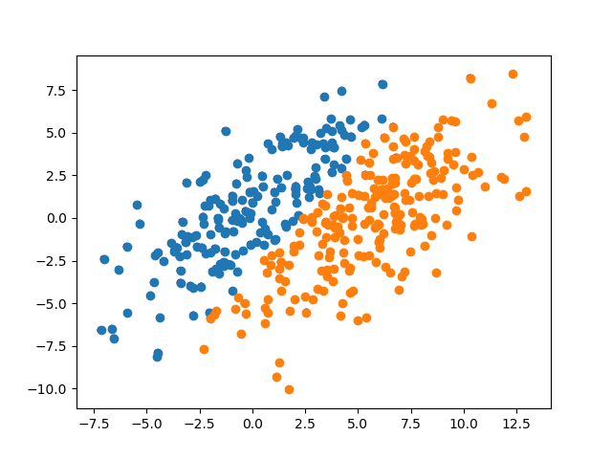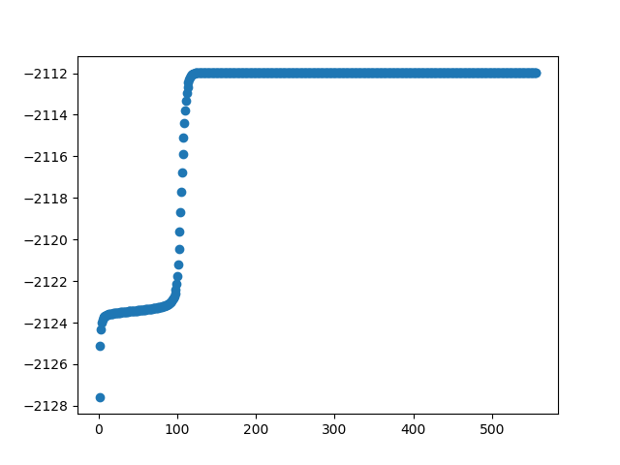





By comparing the result from K-mean and EM, we can conclude that EM has better accuracy compared with K-means. K-means does not identify the real clusters pattern. (It divide two cluster vertically instead of horizontally).

For error percentage, EM has misclassification error of 11.2 and K-mean has 23.5.

In terms of running time, EM usually has more iterations then K-means.